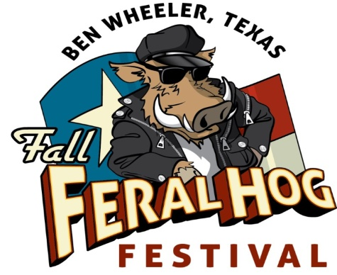
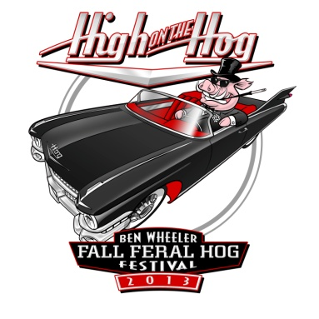
2015 Fall Feral Hog Festival • Ben Wheeler, Texas
World Championship Wild Hog Cook-Off
Saturday, Oct. 24 • Ben Wheeler Festival Grounds
Official Entry Form

TEAM NAME_______________________________________________________________ HEAD COOK____________________________________________________________________
(Please Print) (Correspondence will be communicated with head cook.)

ADDRESS_______________________________________________________________, CITY____________________________________ STATE_________ ZIP______________________

PHONE NUMBER: _________________________________ E-MAIL: _____________________________________________ NUMBER OF TEAM MEMBERS___________

PRIZE CATEGORY YOU PLAN TO PARTICIPATE IN: (PLEASE INDICATE WITH A CHECK-MARK OR X)

______ BEST WILD HOG MEAT ($50 Entry fee) ______ BEST BEANS ($10 Entry Fee) ______BEST WILD HOG CHILI ($10 Entry Fee)

ENTRY FEES ARE NON-REFUNDABLE AMOUNT ENCLOSED: $_____________________

ENTRIES MUST BE RECEIVED NO LATER THAN OCTOBER 16, 2015. LATE ENTRIES WILL BE CONSIDERED ON A SPACE-AVAILABLE BASIS.

There will be three (3) categories of judging:
- Category 1. Best Wild Hog Meat
  - First Place $500 plus 3 Custom Championship Belt Buckle
  - Second Place: $300 plus 2 Custom Championship Belt Buckle
  - Third Place: $200 plus 1 Custom Championship Belt Buckle
- Category 2. Best Beans - $100 plus a Plaque
- Category 3. Best Wild Hog Chili - $100 plus a Plaque

PLEASE READ ALL INFORMATION BELOW

Please Note: ALL INFORMATION REQUESTED IN THIS FORM MUST BE FIILLED OUT. IT IS IMPORTANT THAT WE HAVE THE HEAD COOK’S NAME, ADDRESS, AND PHONE NUMBER ON FILE. IF THERE IS ANYTHING LEFT BLANK, THIS COULD CAUSE DELAY IN ASSIGNING YOUR SPOT.
Due to a concern of liability, the following paragraph is included. Please read it carefully before signing. If this Entry Form is not signed, it will be returned to you and your application will not be valid until the form is signed. It must be signed prior to the deadline to maintain your spot.
“We, the members of the below named team, acknowledge and understand that we are responsible for our own actions during or related to the participation in the 2015 World Championship Wild Hog Cook-Off, and accordingly hereby RELEASE Ben Wheeler Development Company, Ben Wheeler Arts & Historic District Foundation and the municipality of Ben Wheeler from liability (including damages, costs and attorney fees) for any and all accidents or injuries, whether to person or property, that may occur as a result of our participation in the 2015 World Championship Wild Hog Cook-Off during the Fall Feral Hog Festival, Oct. 23 and 24, 2015.

I have read the rules and regulations of Ben Wheeler’s 2015 Fall Feral Hog Fest, World Championship Wild Hog Cook-Off and agree to abide by them. Any violation of the rules and regulations will cause forfeiture of any and all privileges and/or premiums won.
ALSO NOTE: IT IS THE RESPONSIBILITY OF THE HEAD COOK OR TEAM CAPTAIN TO ENSURE THAT ALL TEAM MEMBERS ABIDE BY THE RULES OF THE EVENT AND ALL HEALTH DEPARTMENT RULES AND REGULATIONS. FAILURE TO COMPLY WITH ANY RULE OR REGULATION MAY RESULT IN IMMEDIATE DISQUALIFICIATION. FIREARMS, FIREWORKS, OR OTHER EXPLOSIVE DEVICES ARE PROHIBITED AT THE EVENT.
BY SIGNING BELOW, YOU ARE ACKNOWLEDGING THAT YOU HAVE READ AND AGREE TO ABIDE BY ALL RULES AND REGULATIONS SET BY BEN WHEELER DEVELOPMENT COMPANY, L.L.C. AND BEN WHEELER ARTS & HISTORIC DISTRICT FOUNDATION.

_____________________________________________________________________________________________________________________________________________________________________
HEAD COOK’S OR TEAM CAPTAIN’S SIGNATURE PRINTED NAME DATE

MAKE ENTRY FEE CHECK PAYABLE TO: “BEN WHEELER ARTS & HISTORIC DISTRICT FOUNDATION”
MAIL TO: P.O. BOX 7, Ben Wheeler, TX 75754 or deliver to 13814 State Highway 64 in Ben Wheeler.

Questions? Call 903.833.1070 or e-mail: hogfest@bwdc.net

